Surround SCM 2010 Upgrade Preparation from pre-2008 Surround SCM versions

Depending on whether you are moving to new hardware, or doing an in place upgrade, here are instructions getting upgraded to Surround SCM 2010

If you’re moving to new hardware as part of your upgrade process, follow the instructions below. Otherwise, you can skip to the next section.

- Download and install the same version of Surround SCM and Seapine License Server that you are using in production on the new hardware. You will find links to the most common versions of Surround SCM below. Contact support@seapine.com if you do not see your version/OS listed below.
Windows:
Surround SCM 4.x:
4.0.0: http://downloads.seapine.com/pub/software_old/sscm40x/sscmwin400install.exe
4.0.1: http://downloads.seapine.com/pub/software_old/sscm40x/sscmwin401install.exe
4.0.2: http://downloads.seapine.com/pub/software_old/sscm40x/sscmwin402install.exe
4.0.3: http://downloads.seapine.com/pub/software_old/sscm40x/sscmwin403install.exe
4.0.4: http://downloads.seapine.com/pub/software_old/sscm40x/sscmwin404install.exe
Surround SCM 5.x
5.0.0: http://downloads.seapine.com/pub/software_old/sscm50x/sscmwin500install.exe
5.0.1: http://downloads.seapine.com/pub/software_old/sscm50x/sscmwin501install.exe
5.0.2: http://downloads.seapine.com/pub/software_old/sscm50x/sscmwin502install.exe
5.0.3: http://downloads.seapine.com/pub/software_old/sscm50x/sscmwin503install.exe
5.0.4: http://downloads.seapine.com/pub/software_old/sscm50x/sscmwin504install.exe
Surround SCM 2008.x:
2008.0.0: http://downloads.seapine.com/pub/software_old/sscm2008x/sscmwin200800install.exe
2008.0.1: http://downloads.seapine.com/pub/software_old/sscm2008x/sscmwin200801install.exe
2008.0.2: http://downloads.seapine.com/pub/software_old/sscm2008x/sscmwin200802install.exe
2008.1.0: http://downloads.seapine.com/pub/software_old/sscm2008x/sscmwin200810install.exe
2008.1.1: http://downloads.seapine.com/pub/software_old/sscm2008x/sscmwin200812install.exe

2. Stop Surround SCM and the Seapine License Server in both locations.
3. In the old location, copy the LicenseServDB directory and all sub-directories and paste them in the install directory in the new location. Following are the default install locations:
Windows: C:\Program Files\Seapine\License Server\LicenseServDb
Mac OS X: /Applications/Seapine License Server/LicenseServDb
Linux: /var/lib/splicsvr/LicenseServDb
Solaris: /opt/splicsvr/LicenseServDb
4. In the old location, copy the SCMServDb directory and all sub-directories and paste them in the install directory in the new location. Following are the default install locations

Windows: C:\Program Files\Seapine\SurroundSCM\SCMServDb
Mac OS X: /Applications/SurroundSCM/SCMServDb
Linux: /var/lib/SurroundSCM/SCMServDb
Solaris: /opt/SurroundSCM/SCMServDb

5. Start the Seapine License Server at the new location.

6. Start the Surround SCM Server at the new location.

7. Login to the Surround SCM client, and verify that all active mainline branches have loaded successfully.

8. If all branches loaded successfully, continue to the next section. Otherwise, contact support@seapine.com and attach the Surround SCM Server log.

Using the Surround SCM Analyze Utility

- If you are currently running the Surround SCM Server where you will be running the SCM Analyze Utility, ensure the Surround SCM server is stopped before launching the SCM Analyze Utility.

- When you launch the analyze utility, you can select specific mainlines to analyze from the “File→Open Database…” menu.

- Then, when you’re ready to begin, click the “Analyze” button and select the following options (highlighted in green):

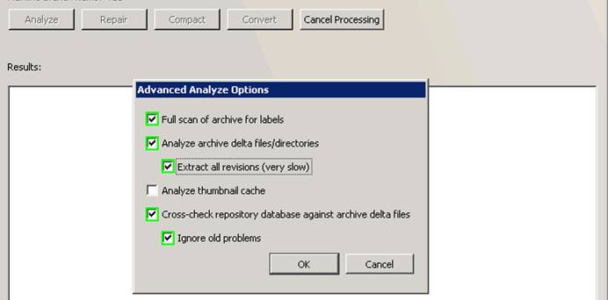

3. Once the analyze is complete, if the analyze utility recommends that you repair, go ahead and run the repair, with same options selected as above.

4. Also, since it is common for users to create repositories and then destroy them, it would be a good idea to click the “Compact” button and use the Compact→Analyze feature to see if any data can be purged.

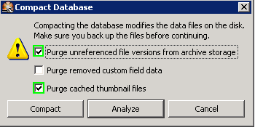

5. If any data can purged, click the “Compact” button again, and click the “Compact” button in the “Compact Database” dialog to compact the database.

If any errors are found that the SCM Analyze utility is unable to repair, please send a copy of the log to support@seapine.com.

